Presentation Of Redis

* Frist we open docker and pull images:

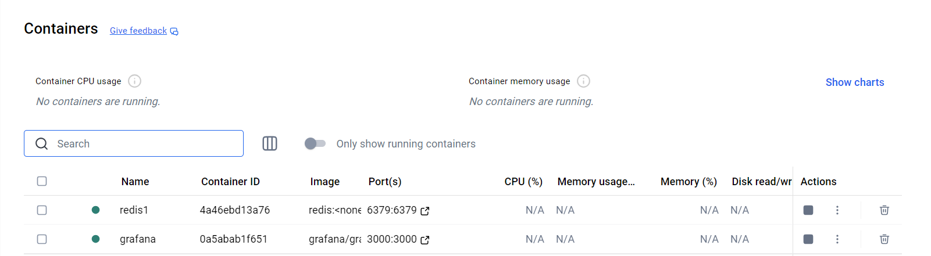

Command: redis-cli

Add data:

Command:

XADD mystream \* Source "web" Amount 250

* Generate two groups to consume data :

Frist to pull data before connecting group :

Second to pull data new data that generated after group creating:

* We make two consumers in different group:

Frist consumer in the first group:

Note: consumer read the hull data from beginning:

* We read data from second group with consumer in this group:

Naw we added data :

Then :

We read data:

Now :

We connect to redis instance:

We show data in the instance:

Press on consumer group to show details of massage delivering:

Now:

We will connect to Grafana with port and IP address:

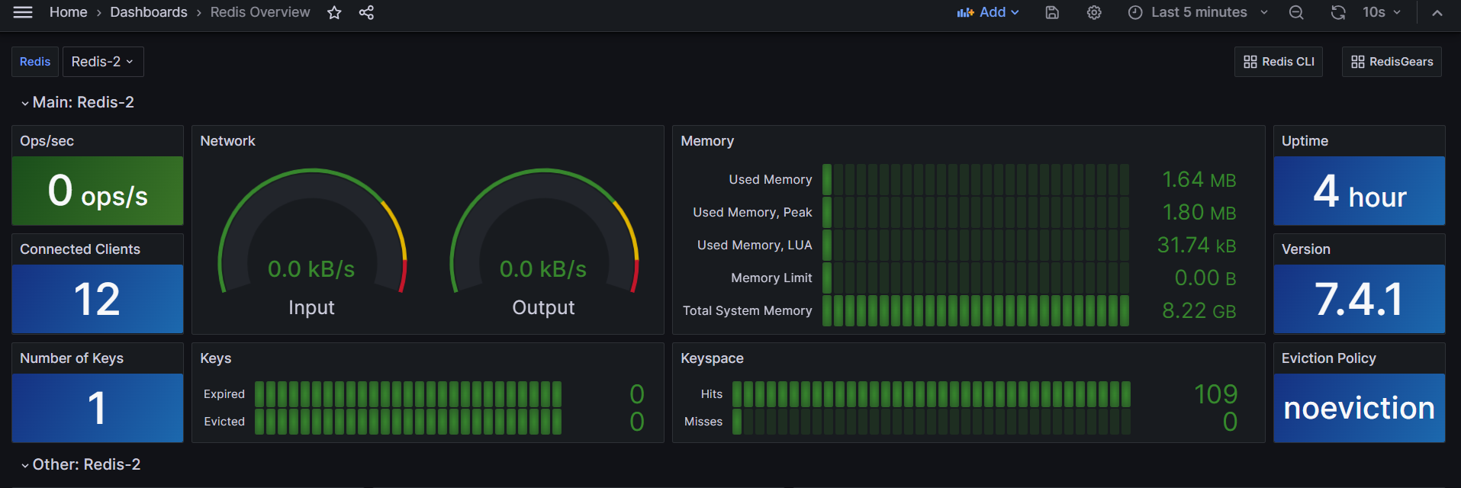

There is One topic ‘Stream’

Now we will add another topic from redis instance :

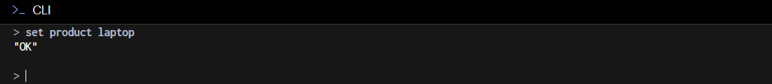

Grafana applied this changes :

